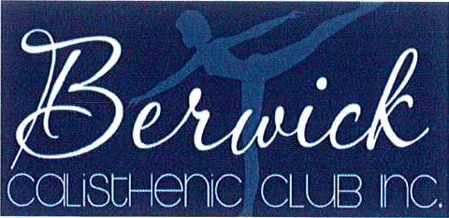
Factory 2, 65-67 Enterprise Ave Berwick 3806
ABN 93263564279 APOO/069P 8.9.1986
Communication and Social Media Policy |  |  | Approval Date: | 12/9/17
 |  |  | Review Date: | 12/9/18
 |  |  | Version No: | 1
President: | Sign: 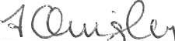 |  | Name Fiona Quigley
VicePresident: | Sign: 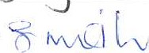 |  | Name Gail Smith
OUR COMMITMENT
Electronic communication is essential for sharing club news and information with our members. Our communication will be timely, appropriate and related to club business.
WHAT WE WILL DO
We use a range of electronic tools to communicate with our members.
Our communication will protect members' privacy, maintain clear boundaries and ensure that bullying and harassment does not occur.
A webmaster will be appointed to provide accountability and control over material published on our club's website and any related discussion groups or social media websites, such as Facebook, YouTube or Twitter.
Website
- Our website will include current information on competitions, social events, committees, policies, constitution, rules and by-laws.
No offensive content or photos will be published.
- If we intend to publish a photo of a child, we will first seek permission from his or her parents and take care not to provide identifying information.
- We will seek feedback from members to improve the information available on the site.
SMS and email
Committee members, coaches and team managers may use SMS and email to provide information about competition, training, club-sanctioned social events and other club business, however:
- SMS messages should be short and about club/team matters
- email communication will be used when more information is required
- communication involving children will be directed through their parents.

Social media websites
- We treat all social media postings, blogs, status updates and tweets as public 'comment'
- Postings (written, photos or videos) will be family-friendly and feature positive club news and events.
- No personal information about our members will be disclosed.
Version 1 2017
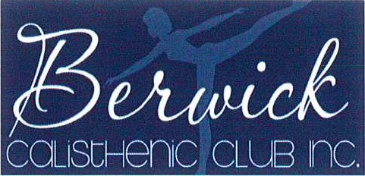
Factory 2, 65-67 Enterprise Ave

Berwick 3806
ABN 93263564279 inco,porated AP001069P 8.9.1986
- No statements will be made that are misleading, false or likely to injure a person's reputation.
- No statements will be made that might bring our club into disrepute.
Abusive, discriminatory, intimidating or offensive statements will not be tolerated. Offending posts will be removed and those responsible will be blocked from the site.
WHAT WE ASK YOU TO DO
We expect our members to conduct themselves appropriately when using electronic communication to share information with other members or posting material on public websites connected to the club. Electronic communication:
- should be restricted to club matters must not offend, intimidate, humiliate or bully another person must not be misleading, false or injure the reputation of another person should respect and maintain the privacy of members must not bring the club into disrepute.
Coaches and others who work with children and young people must direct electronic communication through the child's parents.
NON-COMPLIANCE
Members may face disciplinary action for sending inappropriate electronic communication or posting online content or comments that harass, offend, intimidate or humiliate another member, as outlined in our member protection policy or code of conduct.
Under certain circumstances, cyber bullying (e.g. bullying that is carried out through an internet service such as email, a chat room, discussion group, instant messaging or website) is a criminal offence that can be reported to the police.
In addition, members who publish false or misleading comments about another person in the public domain (e.g., Facebook, YouTube or Twitter) may be liable for defamation.
Version 1 2017

